Simple notification service
(AWS)

A

s

s
Mini Project – I

Name : B . Sivani
Roll No : 24A81A0570
Department : Computer Science and Engineering (CSE)

Abstract :-
This project demonstrates the implementation of Amazon Simple Notification Service (SNS) integrated with an EC2 instance. The objective is to send automated notifications when specific events occur on the EC2 server. AWS SNS is used to publish messages, and subscribers receive notifications via email. This project highlights the practical use of cloud-based messaging services for real-time alerts.
Key Benefits:
- Real-time notifications
- Scalable architecture
- Minimal infrastructure management
- High reliability

Tools Required:

- Amazon EC2
- AWS Simple Notification Service (SNS)
- AWS Simple Queueing Service (SQS)
- CloudWatch
- CloudTrail

Prerequisites :
- An active Amazon Web Services (AWS) account.
- Knowledge of launching and managing EC2 instances.
- Knowledge of SNS Topics and Subscriptions.
- CloudWatch Metrics Availability.
- Basic knowledge about queues , tables and roles.
- Must have subscribers email or phone number.

Implementation Steps :
- In CloudTrail :-
- In it create new trail and give name for it.
- Cloud trail support for free trail.
- In this if we enable the log files validate , then if we delete anything Critical files amazon will inform to company.
- These logs are stored in s3.
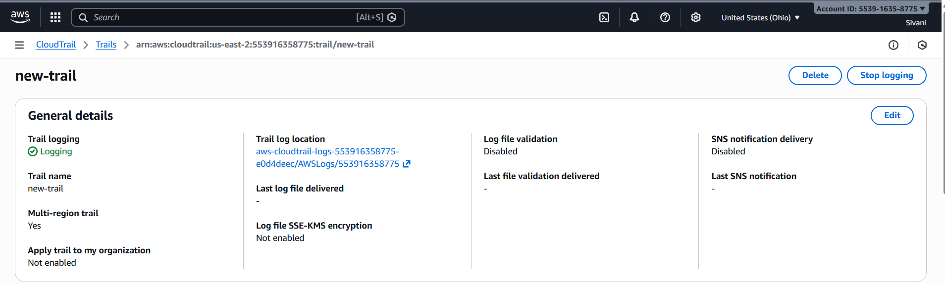
2. Simple Queueing Service (SQS) :-
- Create queue and give name for it.
- Queues hold messages from 0 seconds to 12hours . After that it sent that message to DLQ .
- The Undelivered messages are stored in DLQ . It holds that message from 1 min to 14 days.
- In this max message size is 1024 kiB.
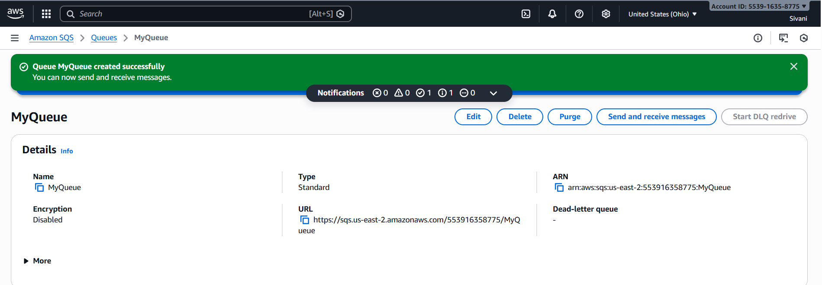
- If we want to send or receive the message click on send and receive messages , give the message and click on sent message .
- But we can’t see that received message directly we need to click on
poll for messages then we can see that message .
3.Simple Notification Service (SNS) :-
- In this we will create topic and give topic name.
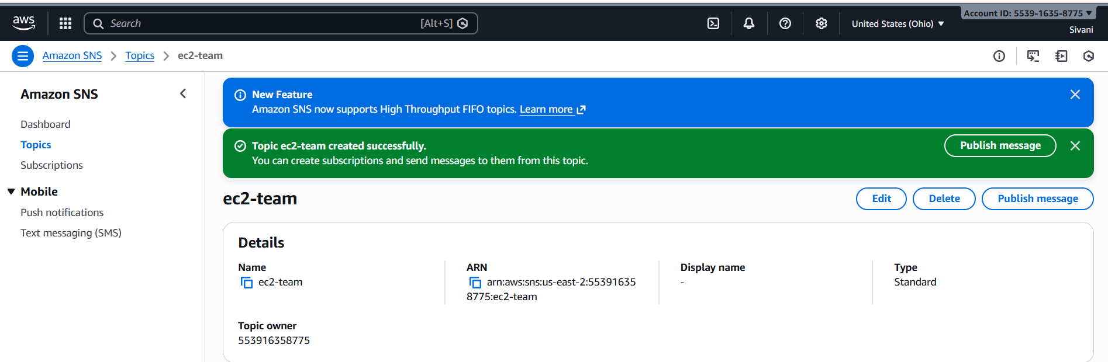
- Next we will create subscribers with protocol email .
- Go to IAM and create role.
- Now go to to SQS Queue in this give permission only for specified AWS accounts. Paste ARN present in thee SNS roles.
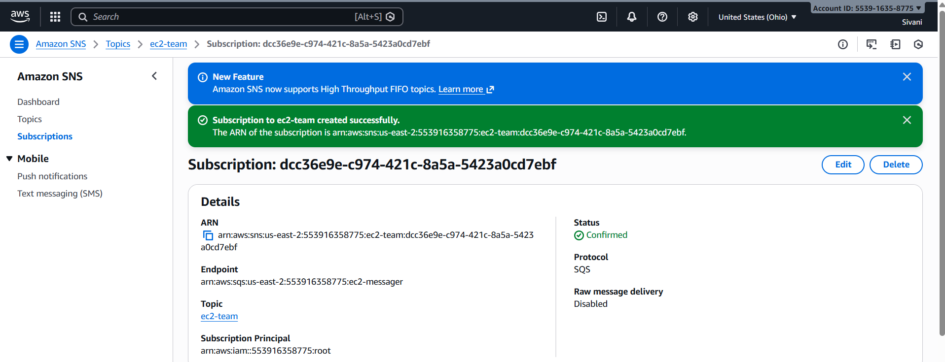
- Now click on your topic you can see confirmed subscriptions.

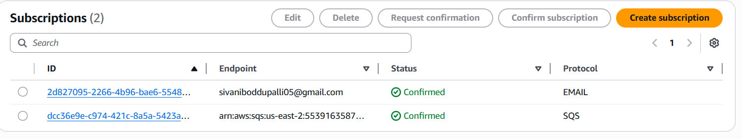

- If you want to publish a message go to publish message give the message and also give body .

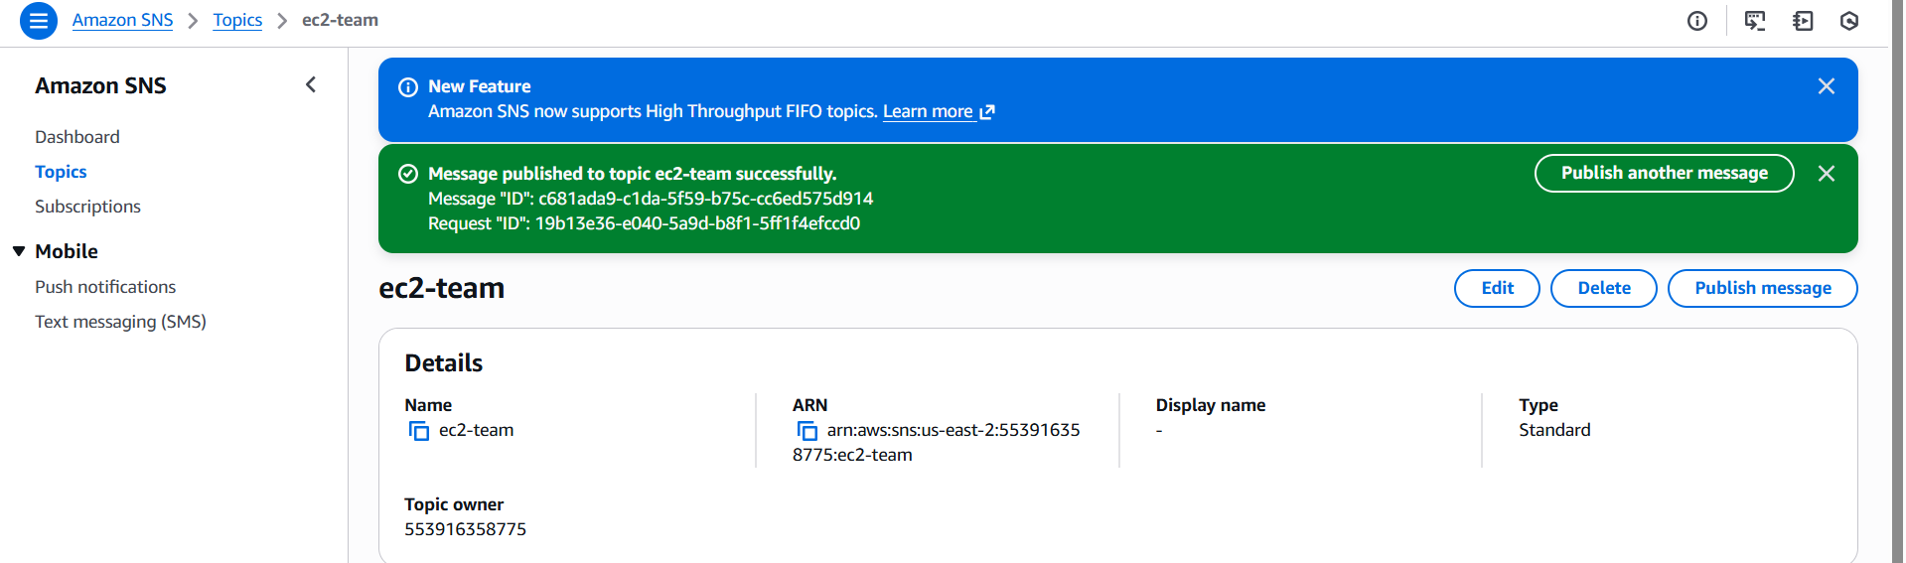

4. CloudWatch :-
- Now go to CloudWatch click on metric and select All metrics take your instance ID and paste here now, select CPU Utilisation option go to Graphed metrics click on the bell icon.
- After that it will take you to create alarm in conditions greater than / equal to “0” .
- Next in configure actions select In alarm and select send notification to your topic.
- Next give warning message and description something related to it and click next.

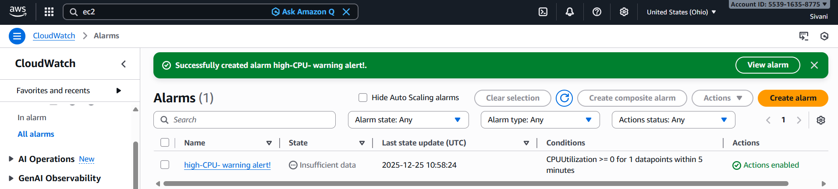

- If we get alarm we can see like that means for Email and SQS notifications sent automatically.
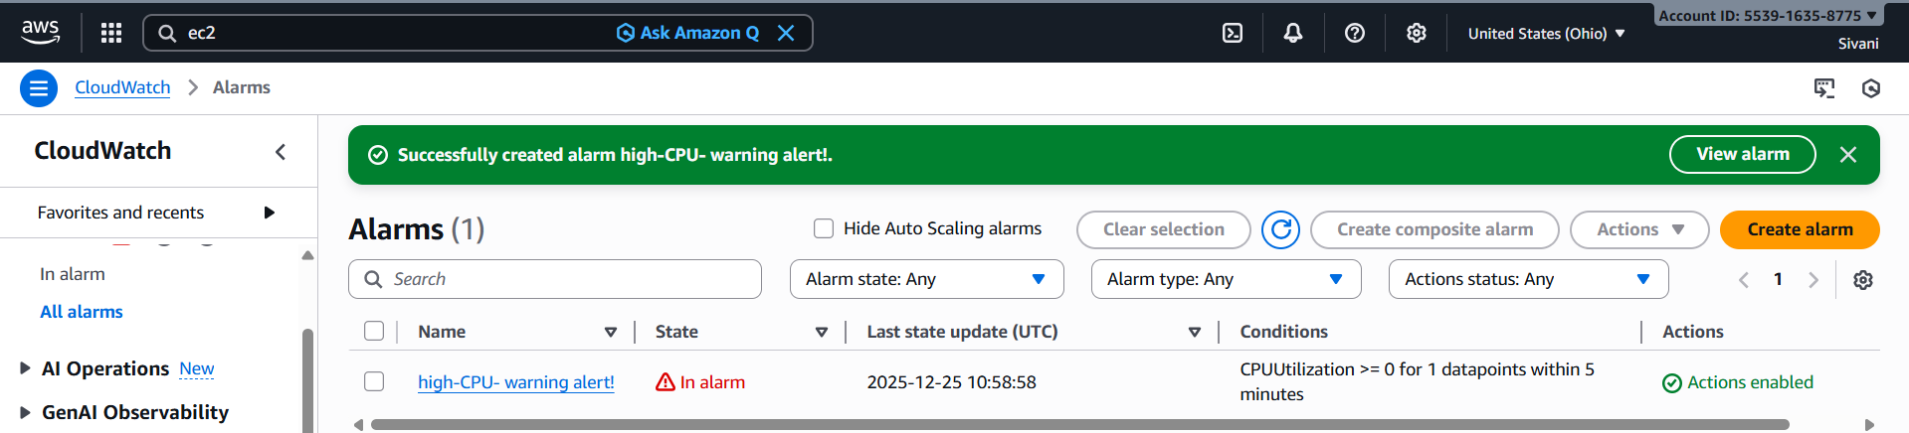
Output :-
- In Email :- we receive a warning message through our Email .
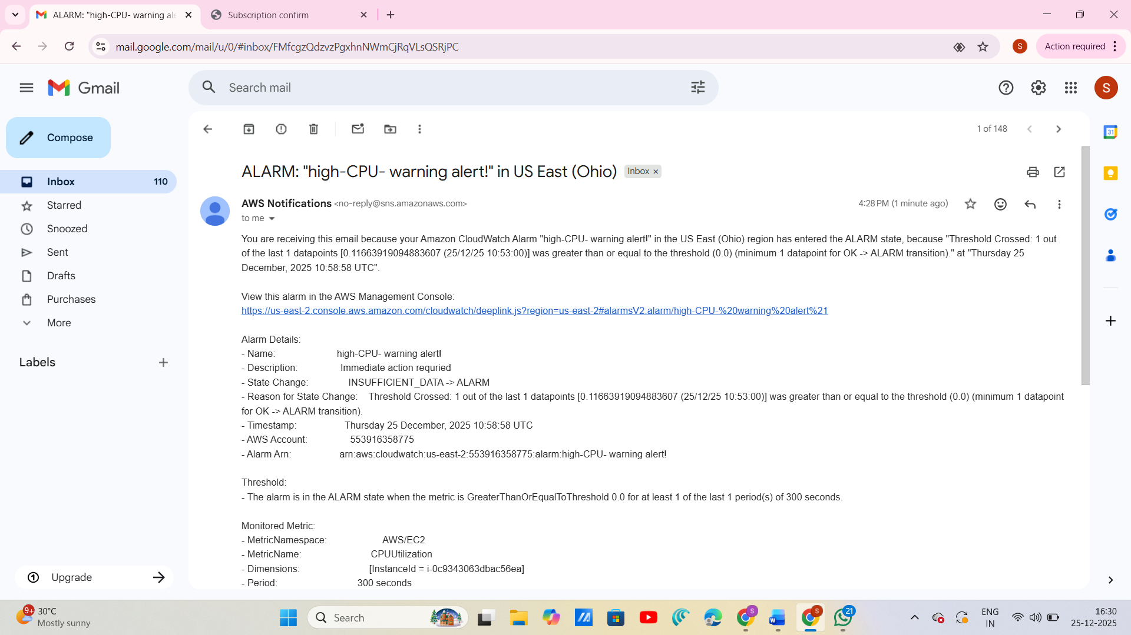

- In SQS :- We an see this warning message by selecting your queue you
Can see send and receive messages. Click on it , In received
Messages click on poll for messages we can see the output.

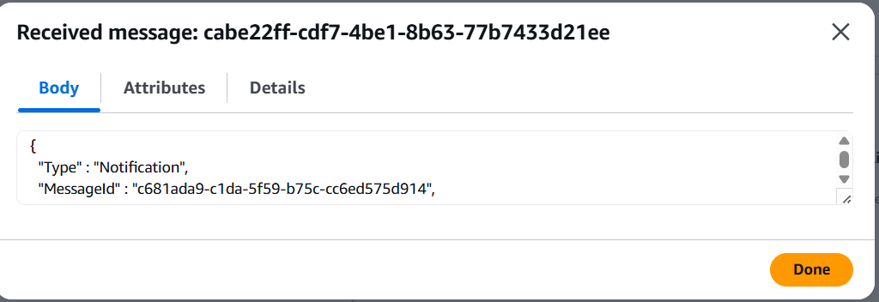

Conclusion :-
This mini project successfully demonstrates the implementation of a cloud-based notification system using Amazon EC2, Simple Notification Service (SNS), CloudWatch alarms, and Simple Queue Service (SQS). The solution enables real-time alerting and reliable message delivery through a scalable and fully managed AWS architecture.
By integrating EC2 with SNS, the system efficiently publishes notifications to subscribed users, while CloudWatch alarms ensure proactive monitoring of system metrics. The inclusion of SQS enhances message durability and fault tolerance by enabling asynchronous communication and handling message failures effectively.
Overall, this project highlights the practical use of AWS messaging and monitoring services to build a secure, scalable, and cost-effective notification framework. The solution reflects real-world cloud implementation practices and can be extended further to support advanced alerting, automation, and enterprise-level applications.

